Mutual Fund Analytics Platform

Final Project Report
Prepared By:
Sayandip Sen
Email: sayandipsen03@gmail.com
Organization:
Bluestock Fintech

Executive Summary
The objective of this project was to develop an end-to-end Mutual Fund Analytics Platform capable of processing, analyzing, and visualizing mutual fund industry data. The system integrates data engineering, financial analytics, risk analysis, and business intelligence techniques to generate actionable insights for investors and analysts.
The project utilized multiple datasets covering mutual fund schemes, historical NAV values, investor transactions, benchmark indices, SIP inflows, category inflows, portfolio holdings, and industry AUM trends. The data was processed through a structured ETL pipeline and stored in a SQLite database for efficient analysis.
Advanced financial metrics including CAGR, Sharpe Ratio, Sortino Ratio, Alpha, Beta, Maximum Drawdown, Value-at-Risk (VaR), Conditional Value-at-Risk (CVaR), and sector concentration measures were computed to evaluate fund performance and risk.
A Power BI dashboard consisting of four interactive pages was developed to provide insights into industry growth, fund performance, investor behavior, and SIP trends. The platform demonstrates the practical application of data engineering, financial analytics, and business intelligence concepts in a real-world investment analytics environment.

1. Project Objectives
The primary objectives of this project were:
- Build a scalable mutual fund analytics platform.
- Design an ETL pipeline for financial datasets.
- Perform exploratory data analysis on industry and investor data.
- Evaluate mutual fund performance using risk-adjusted metrics.
- Analyze investor behavior and SIP continuity.
- Develop a Power BI dashboard for interactive decision-making.
- Generate business recommendations from data-driven insights.

2. Data Sources
The project integrates multiple datasets representing different aspects of the mutual fund ecosystem.
Fund Master Dataset
Contains metadata about mutual fund schemes including:
- Fund House
- Scheme Name
- Category
- Risk Classification
- Expense Ratio
- Fund Manager
NAV History Dataset
Contains:
- AMFI Code
- NAV Date
- Daily NAV
Used for:
- Daily Return Calculation
- CAGR
- Sharpe Ratio
- Drawdown Analysis
Scheme Performance Dataset
Contains:
- Historical Returns
- Alpha
- Beta
- Sharpe Ratio
- Sortino Ratio
- AUM
Investor Transactions Dataset
Contains:
- SIP Transactions
- Lumpsum Investments
- Redemptions
- Investor Demographics
Benchmark Indices Dataset
Contains benchmark values for:
- Nifty 50
- Nifty 100
- Other market indices
Portfolio Holdings Dataset
Contains:
- Stock Holdings
- Sector Classification
- Portfolio Weights
Industry AUM Dataset
Contains industry-wide AUM statistics.
SIP Inflows Dataset
Contains monthly SIP contribution trends.
Category Inflows Dataset
Contains category-wise investment flows.

3. ETL Architecture
The project follows a structured ETL (Extract, Transform, Load) architecture.
Extract Phase
Data was extracted from multiple CSV files.
Input datasets:
- Fund Master
- NAV History
- Scheme Performance
- Investor Transactions
- Portfolio Holdings
- Benchmark Indices
- Industry AUM
- SIP Inflows
- Category Inflows
Transform Phase
Data cleaning operations performed:
Missing Value Handling
Missing values were identified and treated appropriately.
Duplicate Removal
Duplicate records were removed to ensure consistency.
Datatype Conversion
Date columns were converted into datetime format.
Data Validation
AMFI codes were validated across datasets.
Feature Engineering
Additional analytical features were created:
- Daily Returns
- CAGR
- Sharpe Ratio
- Sortino Ratio
- Alpha
- Beta
- Maximum Drawdown
- VaR
- CVaR
- Fund Scorecard
Load Phase
Processed datasets were loaded into:
- SQLite Database
- Cleaned CSV Files
The database served as the central repository for analytics and dashboard development.

4. Database Design
SQLite was used as the project's analytical database.
Key entities:
- Fund Master
- NAV History
- Scheme Performance
- Investor Transactions
- Portfolio Holdings
- Benchmark Indices
Relationships were primarily established using:
- amfi_code
- date
Benefits:
- Lightweight
- Portable
- Efficient querying
- Easy integration with Power BI

5. Exploratory Data Analysis
Industry AUM Analysis
The industry experienced substantial growth between 2022 and 2025.
The dashboard indicates:
- Total AUM ≈ 39M
- Peak growth observed during 2024
- Industry expansion remained strong despite market volatility
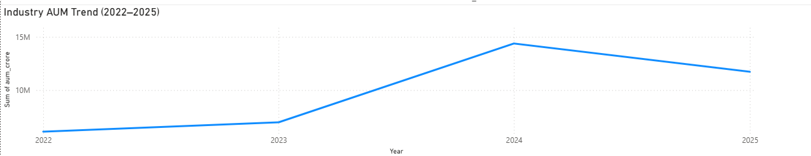
SIP Inflow Analysis
Monthly SIP inflows demonstrated a consistent upward trend.

Key observations:
- SIP inflows reached approximately ₹31K Cr.
- Investor participation increased significantly over time.
- SIP investments remained resilient during volatile periods.
- 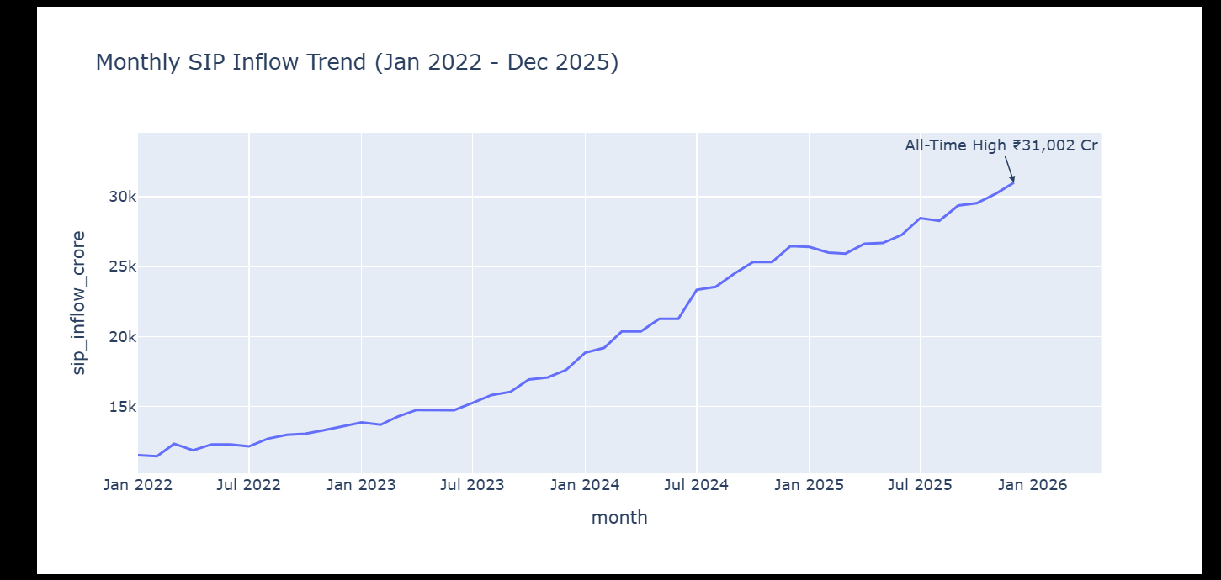

AUM by Fund House
The analysis reveals concentration among major fund houses.
Top contributors include:
- SBI Mutual Fund
- ICICI Prudential MF
- HDFC Mutual Fund
- Nippon India MF
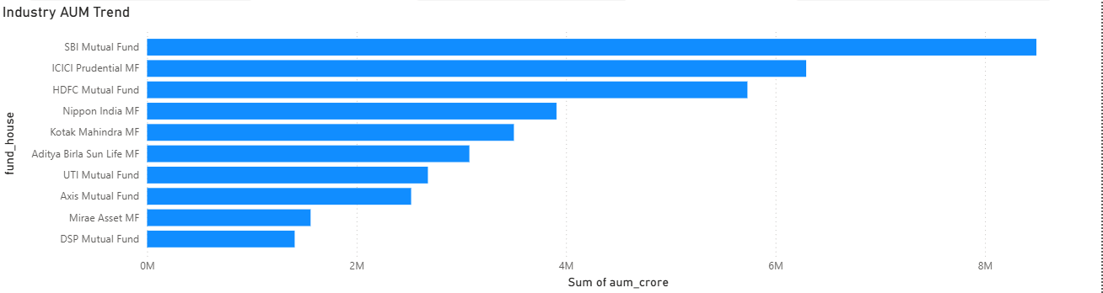

Investor Demographics
Investor participation varied across age groups and geographies.
Findings:
- Significant activity observed among working-age investors.
- Urban investors dominate transaction volume.
- Tier-1 cities contribute a major portion of investment flows.
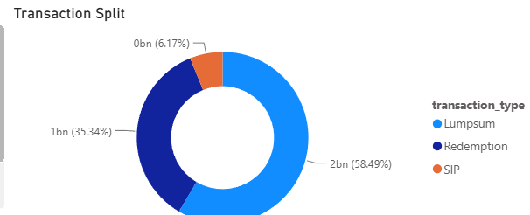
Geographic Analysis
State-level investment analysis shows strong participation from:
- Punjab
- Tamil Nadu
- Madhya Pradesh
- Rajasthan
- Gujarat
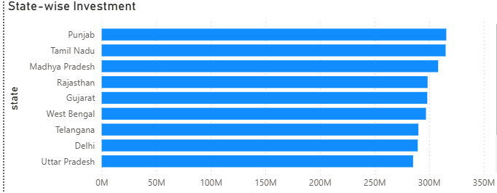
6. Key EDA Findings
- Industry AUM increased significantly from 2022 to 2025.
- SIP contributions reached record levels during the analysis period.
- SBI Mutual Fund managed the largest AUM among analyzed AMCs.
- Investor activity is concentrated in a limited number of states.
- SIP remains the dominant investment strategy for retail investors.
- Category inflows show strong preference for Liquid and Flexi Cap funds.
- Folio counts increased substantially during the study period.
- Tier-1 cities contribute the majority of investments.
- Market growth positively influenced mutual fund inflows.
- Investor participation increased consistently throughout the period.

7. Performance Analytics
Daily Return Calculation
Daily returns were computed using:
Return = NAV(t) / NAV(t-1) - 1
This formed the foundation for all performance metrics.

CAGR Analysis
Compound Annual Growth Rate was calculated for:
- 1 Year
- 3 Year
- 5 Year
Purpose:
Measure long-term wealth creation capability.

Sharpe Ratio
Measures risk-adjusted return.
Higher values indicate better performance per unit of risk.

Sortino Ratio
Measures downside-risk-adjusted return.
Focuses only on negative volatility.

Alpha and Beta
Alpha
Measures excess return relative to benchmark.
Beta
Measures sensitivity to market movements.

Maximum Drawdown
Measures the largest historical decline experienced by a fund.
Used to evaluate downside risk.

Fund Scorecard
A composite score was developed using:
- 30% Return Rank
- 25% Sharpe Rank
- 20% Alpha Rank
- 15% Expense Ratio Rank
- 10% Drawdown Rank
This score was used to rank mutual funds.
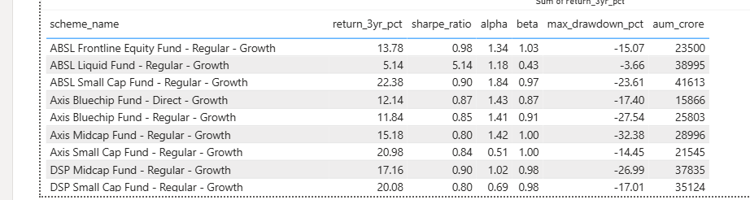
8. Advanced Analytics
Historical VaR and CVaR
Historical Value-at-Risk was calculated at the 95% confidence level.
CVaR was used to estimate average loss beyond the VaR threshold.
Applications:
- Downside risk measurement
- Stress testing

Rolling Sharpe Ratio
90-day rolling Sharpe ratios were computed to analyze risk-adjusted performance through time.
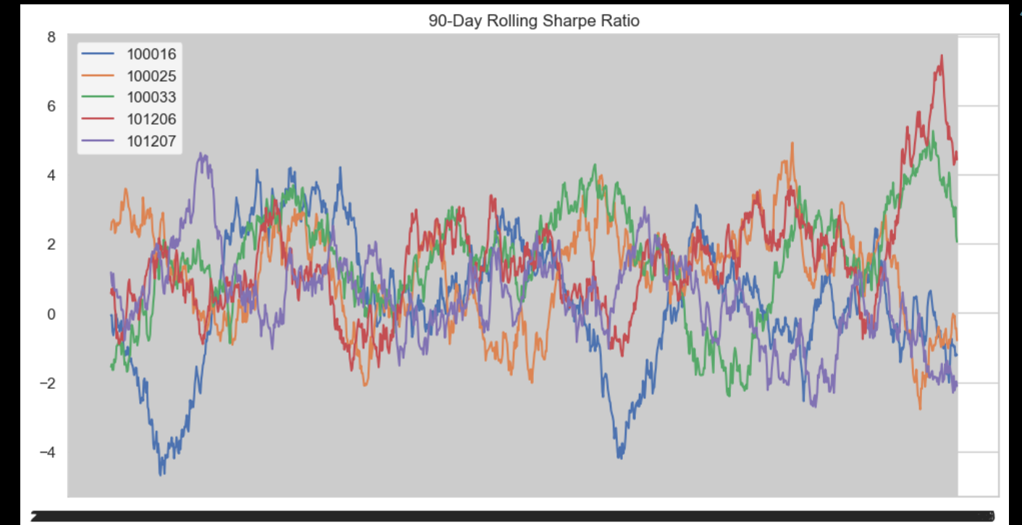
Investor Cohort Analysis
Investors were grouped by first transaction year.
Metrics analyzed:
- Average SIP Amount
- Total Investment
- Preferred Funds

SIP Continuity Analysis
Investors with more than six SIP transactions were analyzed.
At-risk investors were identified when:
Average Gap > 35 Days
This helps identify potential redemption risk.

Sector Concentration Analysis
Herfindahl-Hirschman Index (HHI) was used to measure concentration.
Higher HHI values indicate:
- Lower diversification
- Higher concentration risk

Fund Recommendation Engine
A recommendation system was developed based on:
- Risk Appetite
- Sharpe Ratio
- Risk Grade
Categories:
- Low Risk
- Moderate Risk
- High Risk

9. Power BI Dashboard
The dashboard contains four pages.
Page 1: Industry Overview
Features:
- Total AUM
- SIP Inflows
- Total Folios
- Industry AUM Trend
- AUM by AMC
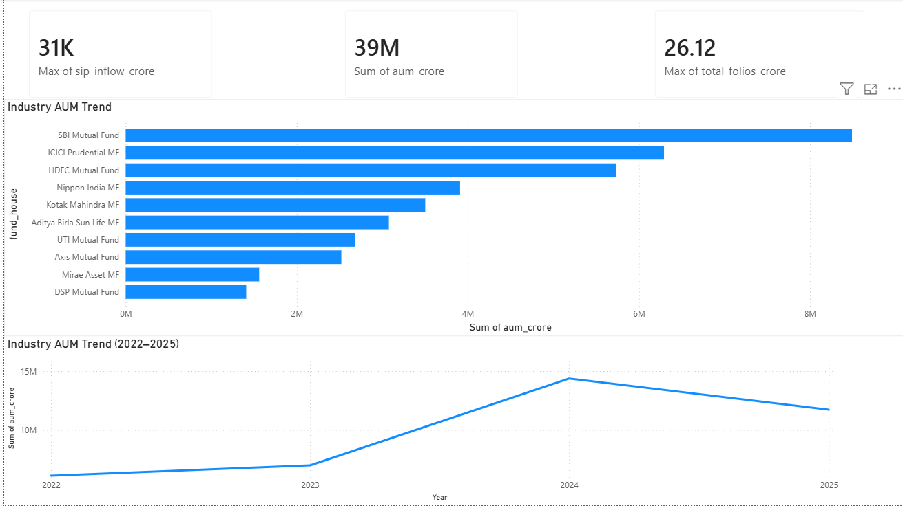
Page 2: Fund Performance
Features:
- Return vs Risk Analysis
- NAV vs Benchmark
- Fund Scorecard
- Interactive Filters
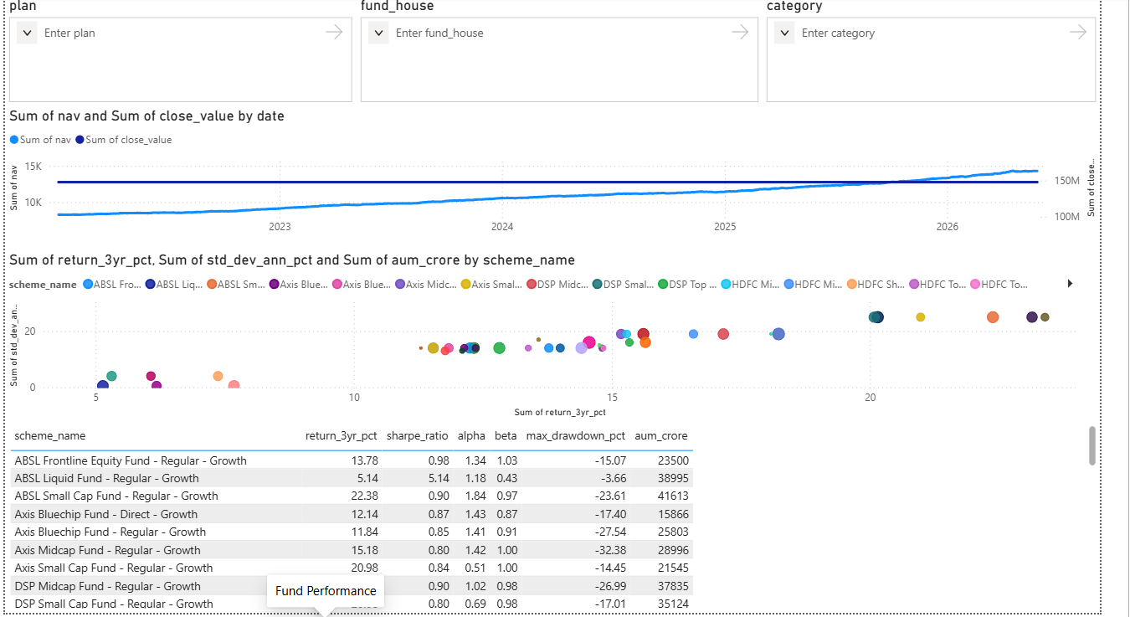
Page 3: Investor Analytics
Features:
- State-wise Investments
- Transaction Distribution
- Age Group Analysis
- Monthly Trends
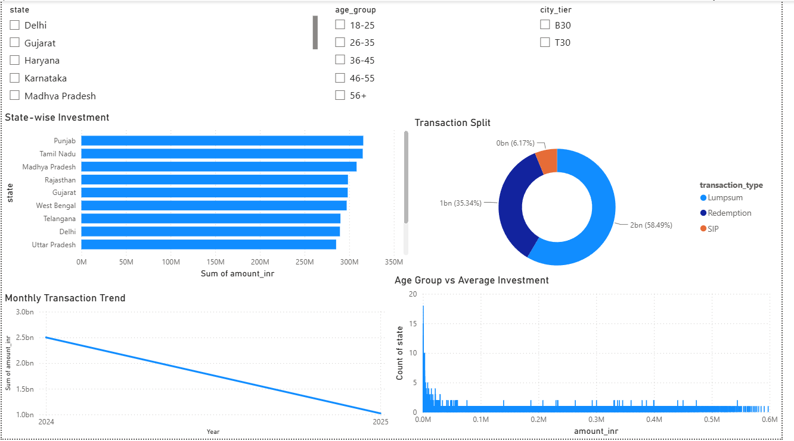
Page 4: SIP & Market Trends
Features:
- SIP vs Nifty Comparison
- Category Heatmap
- Top Categories by Inflow
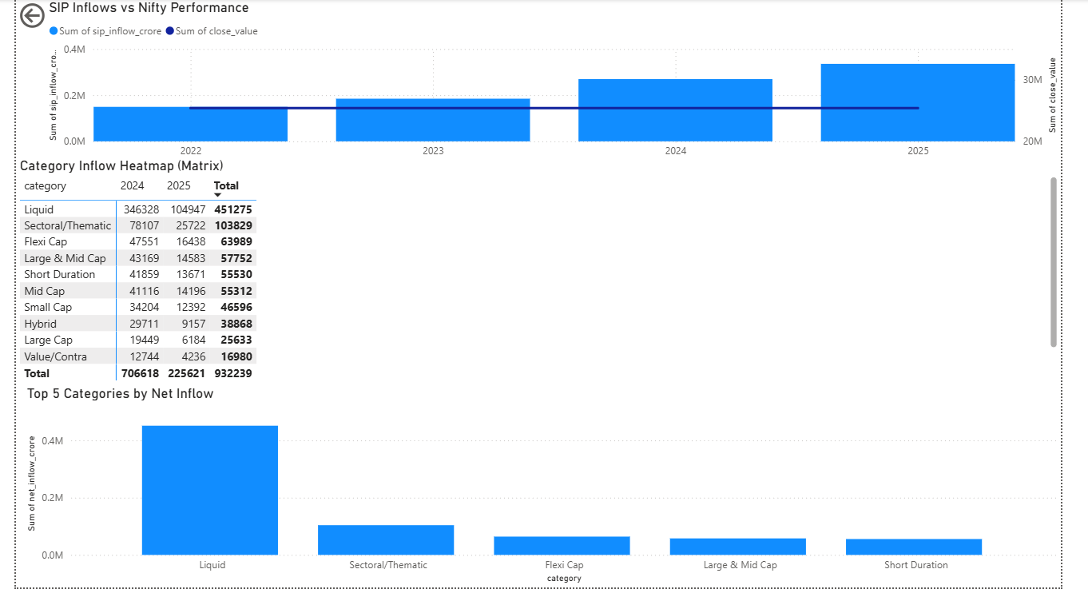
10. Limitations
The project has the following limitations:
- Historical coverage is limited to available datasets.
- Benchmark alignment may vary across schemes.
- SQLite is not designed for large-scale enterprise workloads.
- Future market conditions may differ significantly from historical patterns.
- Some advanced risk models were outside project scope.

11. Recommendations
Based on the analysis, the following improvements are recommended:
- Integrate real-time AMFI data APIs.
- Deploy the platform on cloud infrastructure.
- Add predictive NAV forecasting models.
- Develop portfolio optimization modules.
- Implement investor alert systems.
- Add anomaly detection for unusual fund behavior.
- Introduce personalized fund recommendations.
- Expand risk analytics coverage.

12. Conclusion
This project successfully developed a complete Mutual Fund Analytics Platform integrating data engineering, financial analytics, risk analysis, and business intelligence. Through a structured ETL pipeline, SQLite database implementation, exploratory analysis, advanced financial metrics, and interactive Power BI dashboards, the system provides valuable insights into mutual fund performance, investor behavior, and market trends.
The platform demonstrates practical application of Data Engineering, Data Analytics, Financial Analytics, and Business Intelligence concepts and can serve as a foundation for future investment intelligence systems.

